FACULTY EVALUATION
Programme Name: SEP Scale Alumni Masterclass Module 1 Tanzania (11th May 2026 - 15th May 2026)
Session: Business Plan reviews
Faculty Name: Dr. Isaac Muiruri Gachanja
No. of Respondents: 11
No. of Participants: 11
Evaluation Parameter | (%) Individual Score | (%) Programme Average
Punctuality (Commencement and Completion of Sessions) | 95 | 92
How well do you understand the core concepts presented? | 95 | 88
Rate your confidence in applying the new skills learnt | 88 | 85
Degree of Faculty preparedness for the sessions | 96 | 90
Content and methodology of the program | 96 | 90
Quality of class and group discussions | 95 | 89
The information presented in the course is relevant to my work (ministry) | 98 | 92
Average scores | 95 | 89

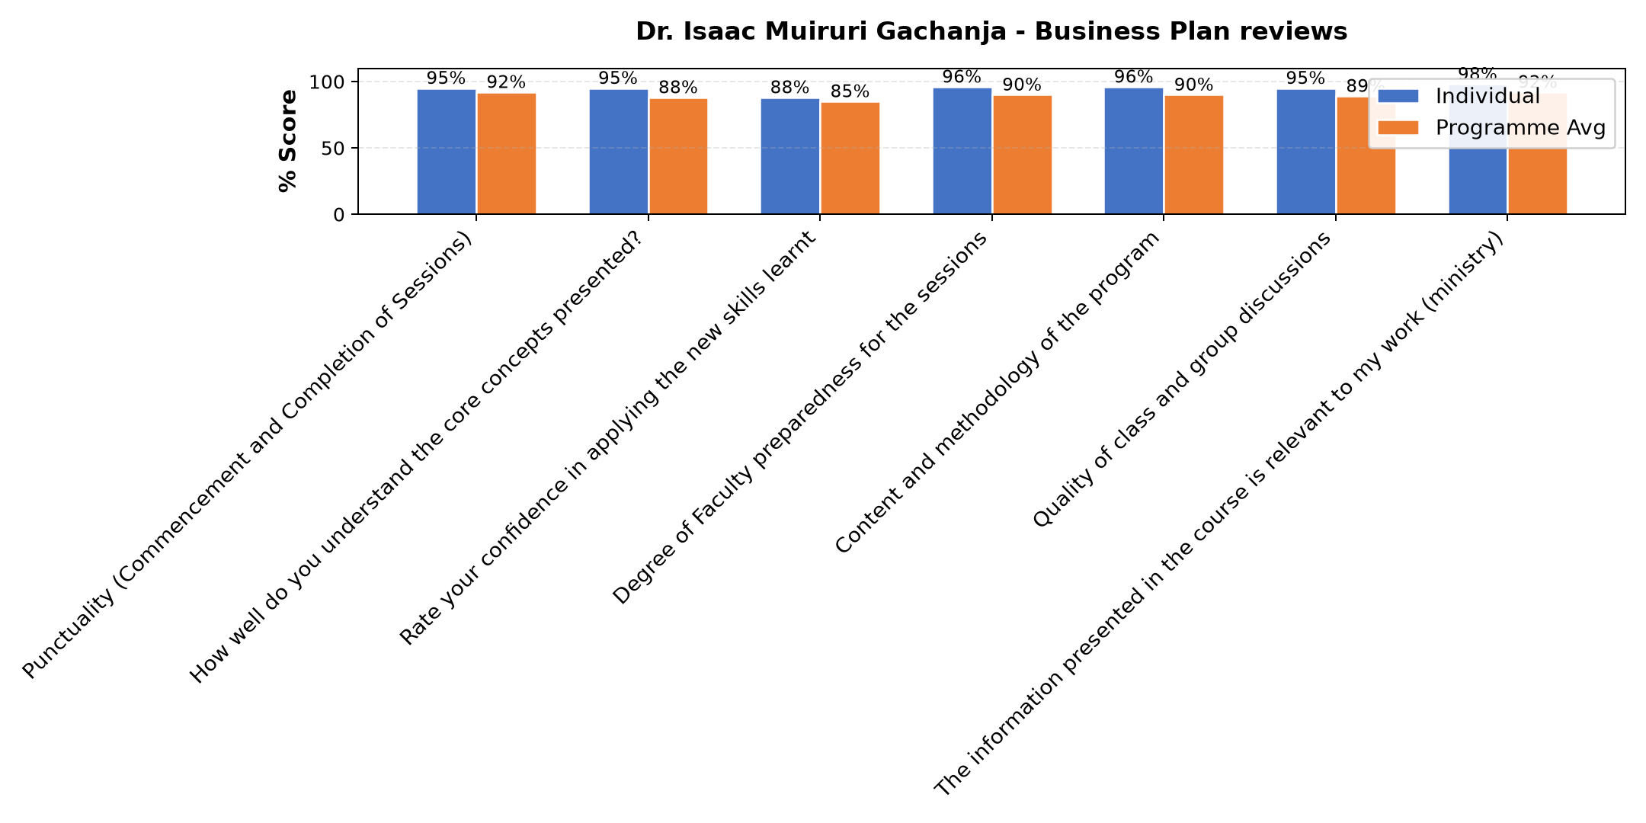

Comments & Feedback
- • Network
- • The barries might prevent me to apply that i learned is Lack of capital, limited experience, and fear of risks may prevent me from applying what I learned about business plan reviews.
SUBMITTED THROUGH:
SBS Evaluation Automation System

